Here is a summary of the key information from Oxfam’s ‘Water For All’ website relating to reasons why water shortage occurs.

Reason for Water Shortage | Why it is a problem
Infected water  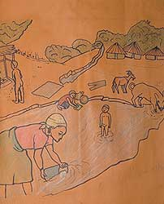 | Germs can make water unsafe for people.  When people have to drink water that is also used for washing and toilet waste, for example, there is a risk of illness.  This poster shows how a useful pond can become infected with germs.
Pollution  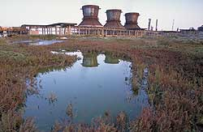 | Pollution from large farms and factories can spoil people’s water supply, making it unsafe to drink. Around the world, chemicals cause sickness when they are allowed to get into the water cycle.  Factories in Azerbaijan pumped acids and other chemicals into the local water sources.
Large-scale irrigation  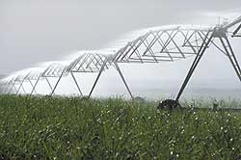 | Big farms and factories use lots of water. Sometimes this means there's less water for the people who live nearby.  Cheap crops such as sugar and tobacco are grown around the world. They are sold in shops and supermarkets in countries such as Britain.  Tobacco and sugar plantations need tons of water for irrigation.
Dams  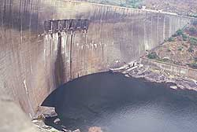 | Big dams are built on rivers all around the world. Sometimes people who live along the river from the dam are left with much less water to use.  If their homes are behind the dam they may be flooded out. Then they are forced to move to drier areas.
Tourism and Trade  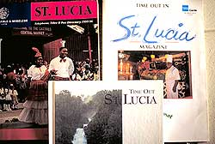 | Holidays can be great fun. Yet in parts of the world where water is scarce, tourist hotels can leave local people with less water to use.  This picture shows adverts for holidays in St Lucia. St Lucia is one of the Windward Islands. Inviting trade and tourism with rich countries does not always benefit local people.
War  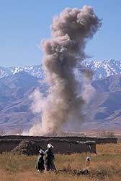 | Weapons cause all kinds of damage.  Weapons hurt and kill people and animals, but they can destroy water supplies too.  Wars may force people to move away to where water is scarce.  This picture shows a bomb being blown up to make it safe. It has been left behind in Afghanistan after war.
Drought  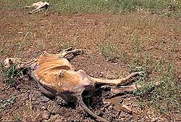 | When there is no rain and everything dries out it is called a 'drought'. Drought can leave people with major water shortages.  People who have the least water are the first to suffer. They don’t have stores of food and water to keep them going, nor the money to buy their way out of trouble.  When the dry season goes on too long, animals and humans suffer alike.

